Recognized Pattern: FakeDoc_variety1

Recognized app name: Sanity

The name of the sample app corresponding to the pattern identified: Battery SuperCharger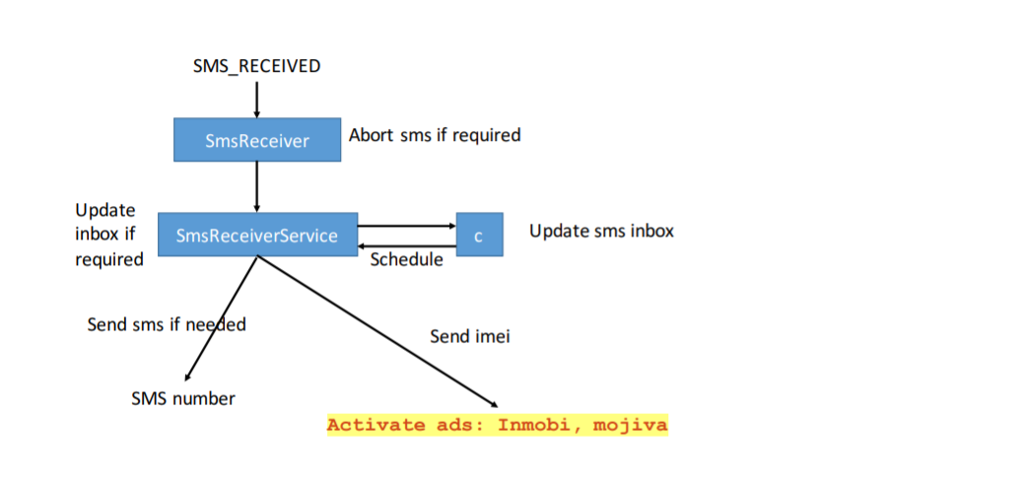

For functional modules:

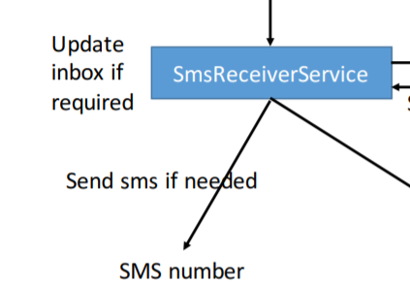

Corresponding to the key code in the identified app:

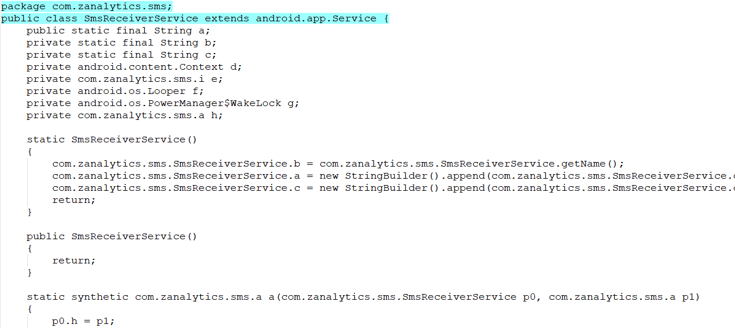

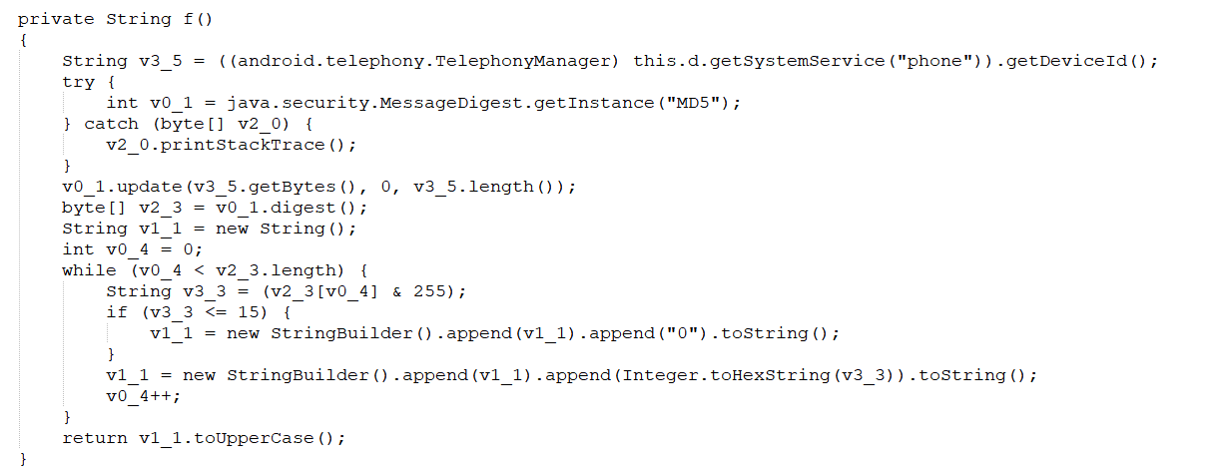

Corresponding to the key code in this app:

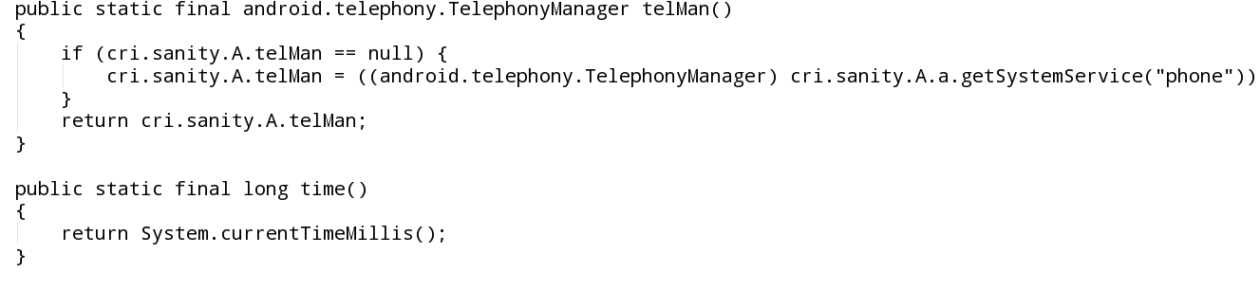

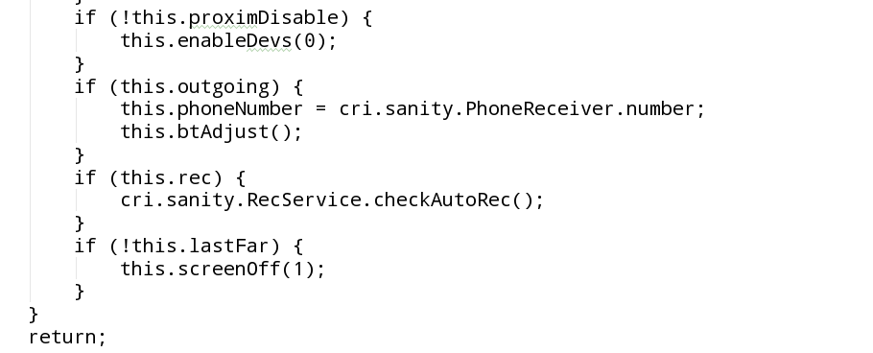

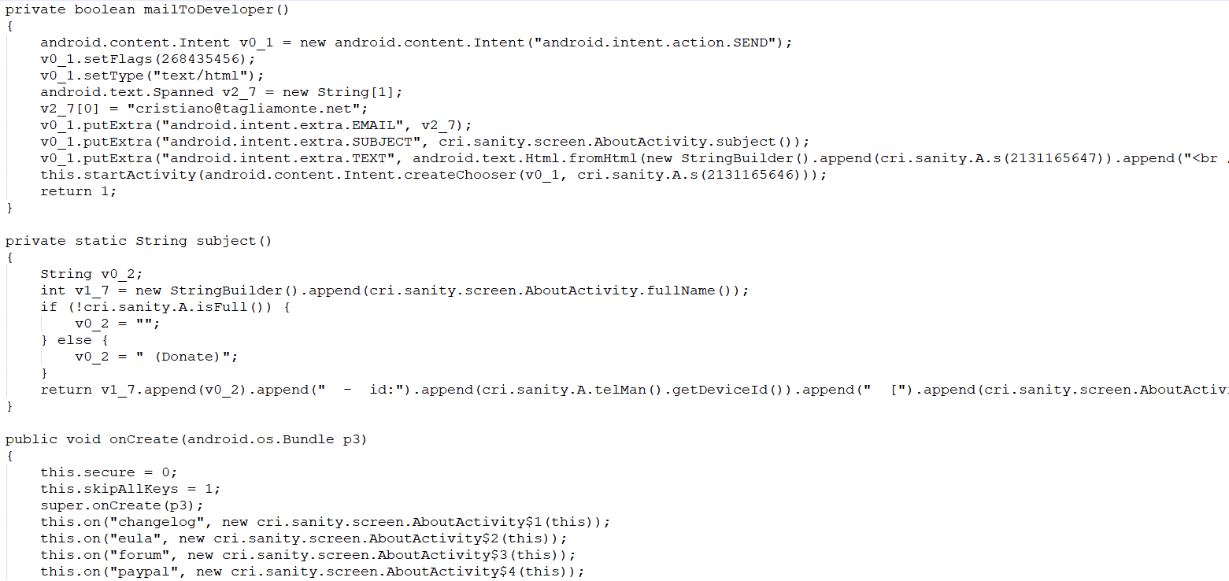

For functional modules:

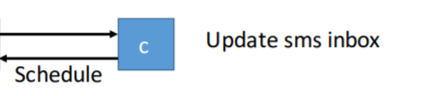

Corresponding to the key code in sample app:

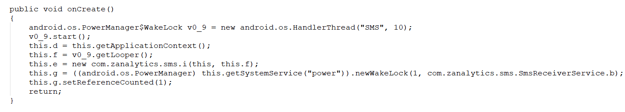

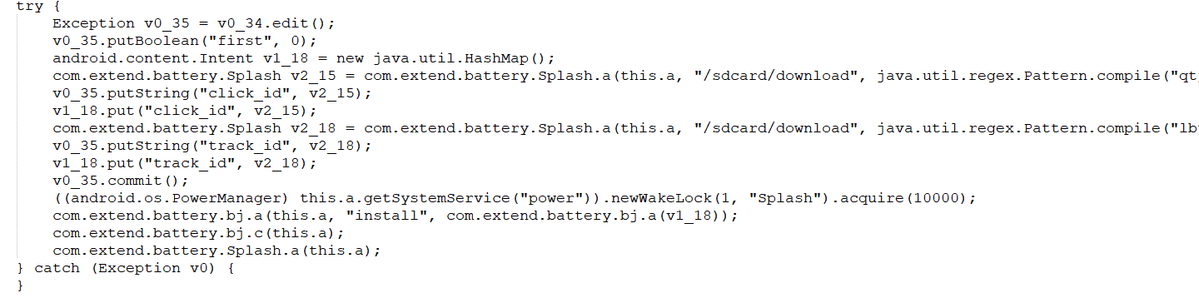

Corresponding to the key code in this app:

